Reference: <https://www.youtube.com/watch?v=sXQI_0ILEW4>

Before you start coding first add in a Plane and Cube in unity

By going to the top left of screen and selecting

**GameObject - 3D object - Plane or Cube**

Then as your cube will appear through the plane you will have to move it up wards to .5, to do so select the cube and go to the left side of the screen and on the right of **Position Y** change the 0 to .5.

Next add in a light for the scene so you will be able to see the cube and plane in game. To do so select again **GameObject** and under the **Light** tab select **Directional Light**.

Now you can add a colour of your choice to the Plane and Cube, to do this you will need to add a material by **Right Clicking** in the **Assets box** at bottom of screen and selecting **Create** then **Materia**l. Do this twice for both objects and call them cube and plane.

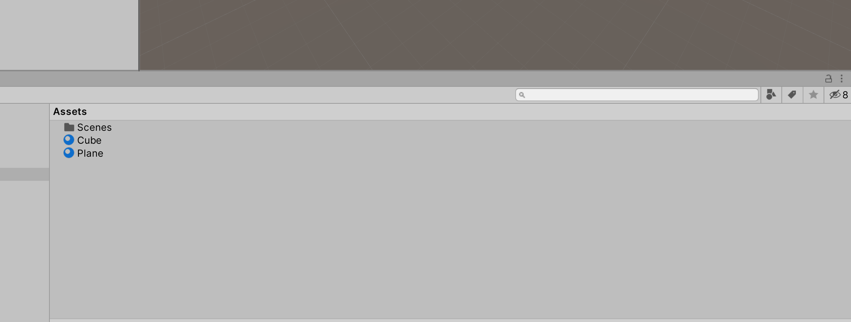

Then to add the material to the object you select and hold the material and drop onto the object with the same name. Then change the colour for what you like by again selecting the material on the right side selecting the pen icon and changing the colour.



Now you will start making a script for the Cube, by right clicking in the assets section and selecting create and **C# Script**. Then click the cube which will highlight it and open on the right side of your screen the cubes inspector which you can edit the cube.

Drag and drop the script at the bottom of the inspector and double click the script to open visual studios.

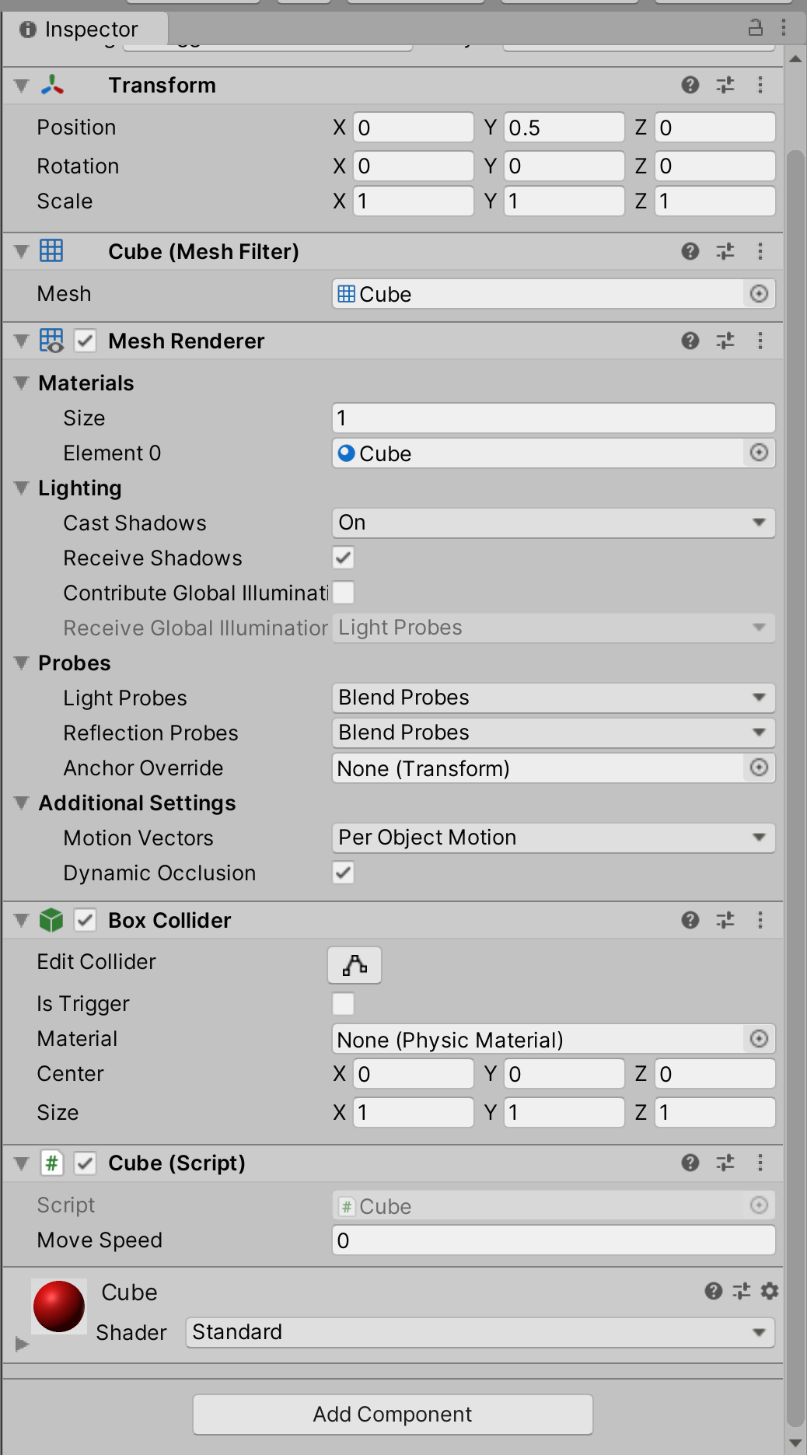

Now you will have to do a small piece of code to make the cube go forward and back.

**Here is the code:**

public class Cube : MonoBehaviour {

public float moveSpeed;

// Start is called before the first frame update

void Start()

{

moveSpeed = 5f;

}

// Update is called once per frame

void Update()

{

transform.Translate(moveSpeed*Input.GetAxis("Horizontal")*Time.deltaTime,0f, moveSpeed*Input.GetAxis("Vertical") * Time.deltaTime);

}

}

This code represents for “Horizontal” the move speed which is 5f multiple the in put which is arrow key makes it go up.

Then the “Vertical” represents the same as speed times in put however left are right.

5F can be changed to the speed you want 1 being slow and 10+ meaning faster.